SR UNIVERSITY
Scholl of Computer Science and Artificial Intelligence
Mid Term Examination: March, 2025
Program: B.Tech 3rdYEAR / IInd SEM
21CS135: DEEP LEARNING

Time: 01 hour Maximum Marks:15
Date:05/03/25 Enrollment No.: _______________
*Assume any Missing data
Q. No. | Question | Marks | CO
1. | Implement the adagrad optimization for following network up to 1 iteration. Where η=0.2, ε=10^{-8,} target output is 0.5.  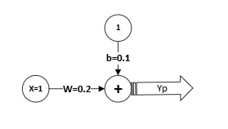 | 7 | CO1
2. | Find the proper weights and bias to reduce the loss in single layer neural network after one iteration. Where target output is 0.9. learning rate is 0.1  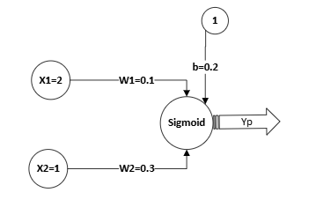 | 8 | CO3

